OUTPUTS OF PROGRAMS

8 BIT DIVISION

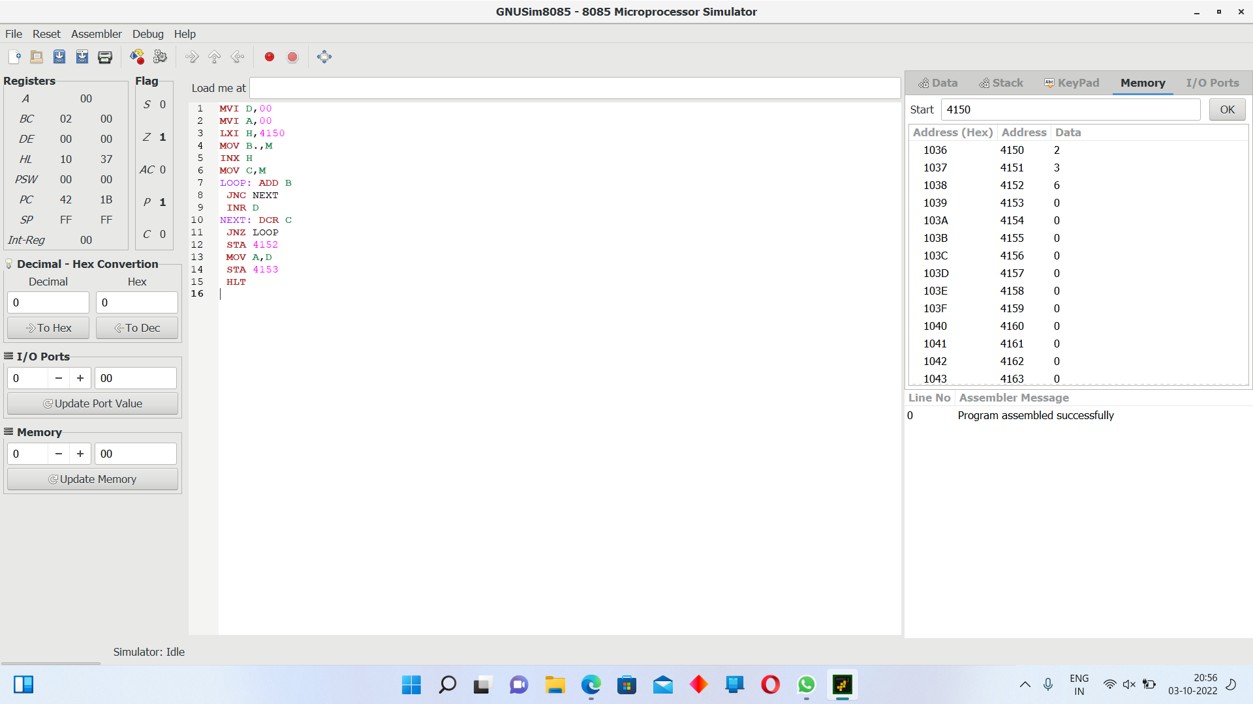

8 BIT MULTIPLICATION

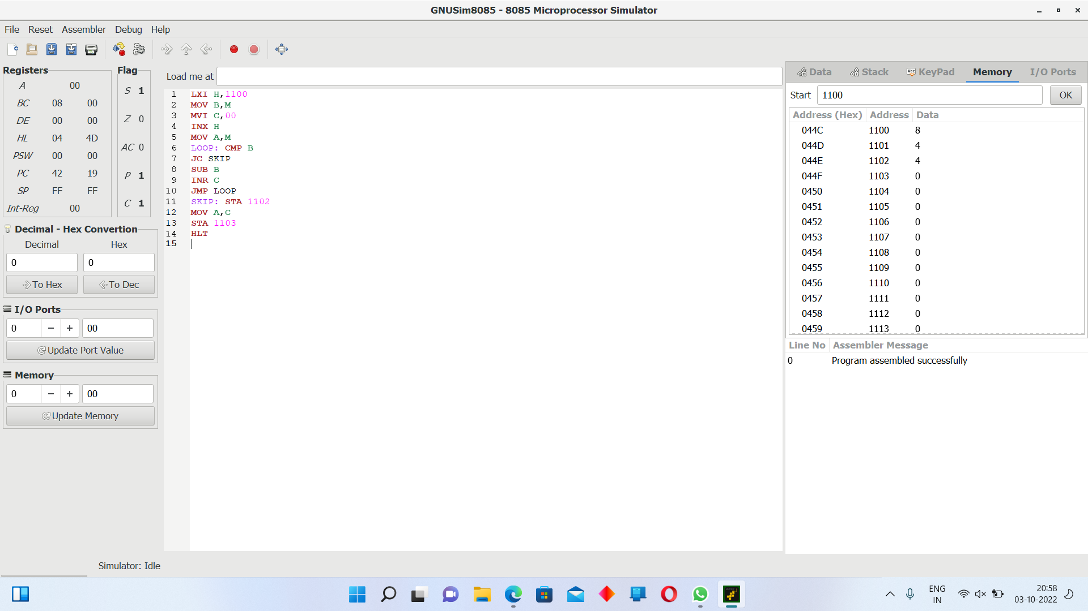

8 BIT SUBTRACTION

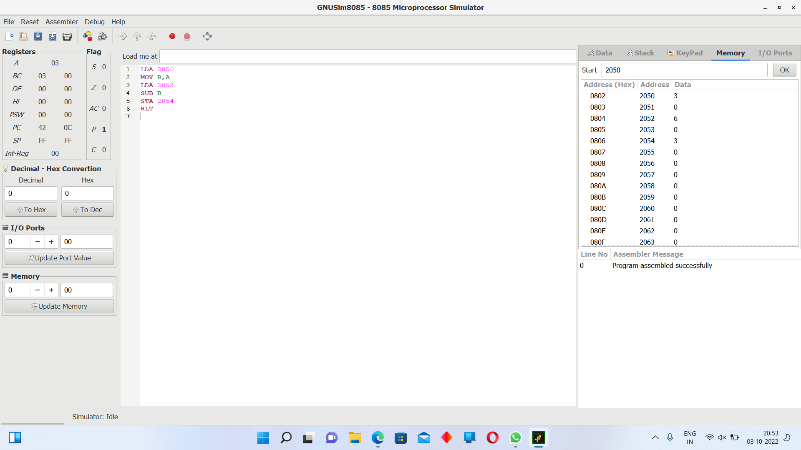

8 BIT ADDITION

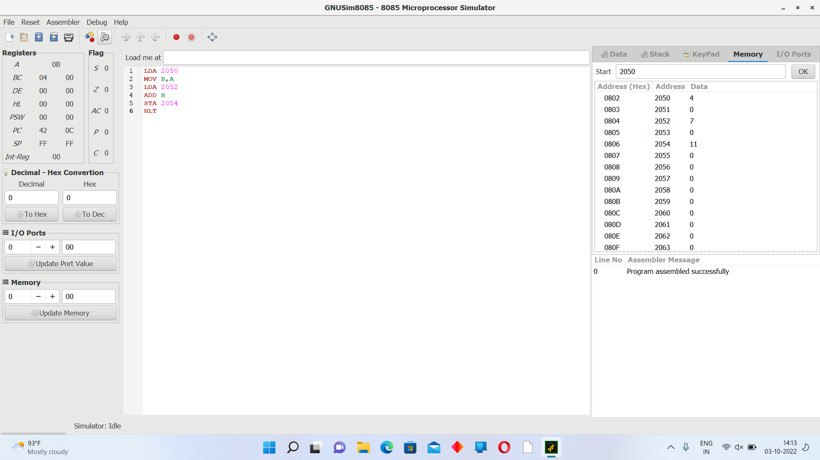

16 BIT ADDITION

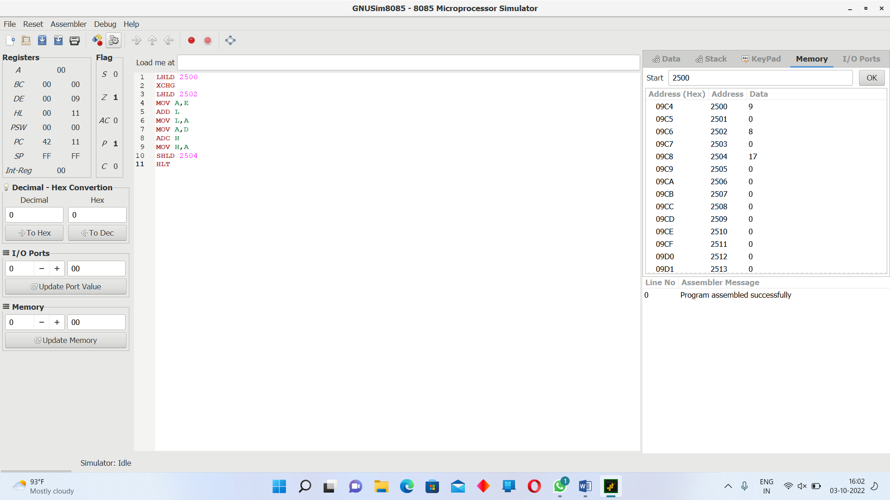

16 BIT SUBTRACTION

